**Spartan Market**

**Team 17**

Maan Singh

Tien Ly

Ge Ou

**Project Requirement**

* **Project Description**

The database application we are proposing is titled ‘Spartan Market.’ The application is to serve students who enjoy shopping and want to save money from the shopping. “Spartan Market” has cheaper men’s, women’s, books and stationery from around the world. Items come directly from factories around the world, and we lower the cost of renting stores and hiring workers. We only have warehouses and internet to manage the market. Our pricing items are cheaper than the others.

Additionally, when we get the location from the customer, we would give the lower pricing based on his/her location that items were produced there. Because the long distance delivery fee will be saved.

Nowadays, people spend a lot of time on social media and watching videos. Although people can relieve stress when they use these applications, when they are off, people feel lonely and make them want to go online again which can lead to an addiction. These forms of entertainment do not bring real happiness to people.

According to Felecia in “10 Benefits Of Reading”, she mentions that reading helps people to learn and improves memory, develop good analytical skills, expand their vocabulary, improve writing skills, relaxation, improve concentration, inspire them, even reading with their kids to increase time with families, improve their language skills, and wrap up. We want to create a platform for people who like to read and make that experience worthwhile for them.

The application would have many kinds of books such as Children’s Books, Novels, Magazines, Textbooks, etc. We also plan on selling school supplies and swag and we want to make this a go-to application for SJSU students. Unlike the school bookstore, we want to allow users to get supplies at a lower price.

* Stakeholders
  + SJSU Students - The targeted user base for our application are the students of the university, so they serve as the primary stakeholders in this project.
  + Team 17 - As developers of this application, we are heavily invested in this project and we want to be able to have this application used by our fellow students.
  + Professor Wu - Professor Mike Wu will be overlooking our project to completion and will be our best resource if we need anything.
* **System Environment**
  + Structure of the system

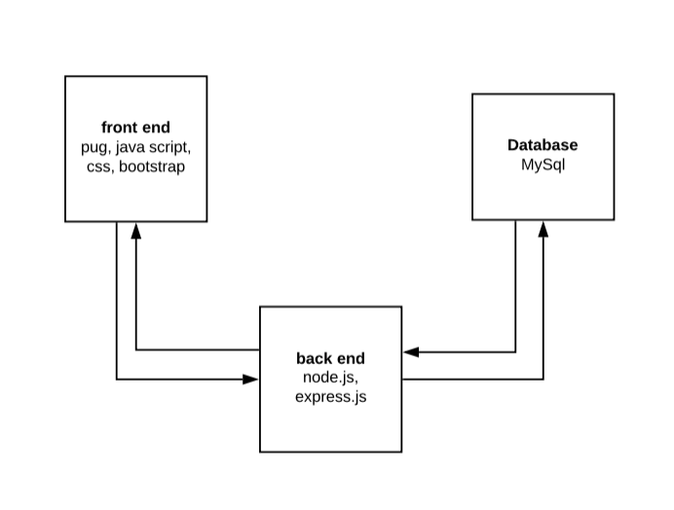

* + RDBMS used is MySQL.
  + Languages used is JavaScript.
  + Software for backend is Node.js, Apache HTTP Server
  + Software for frontend is React.js, HTML.
* **Functional Requirements**
* Describe users and how users can access your system

**Users** could:

* + - create a new account: users could create a new account to set their username, password, their first name and last name, and their phone number.

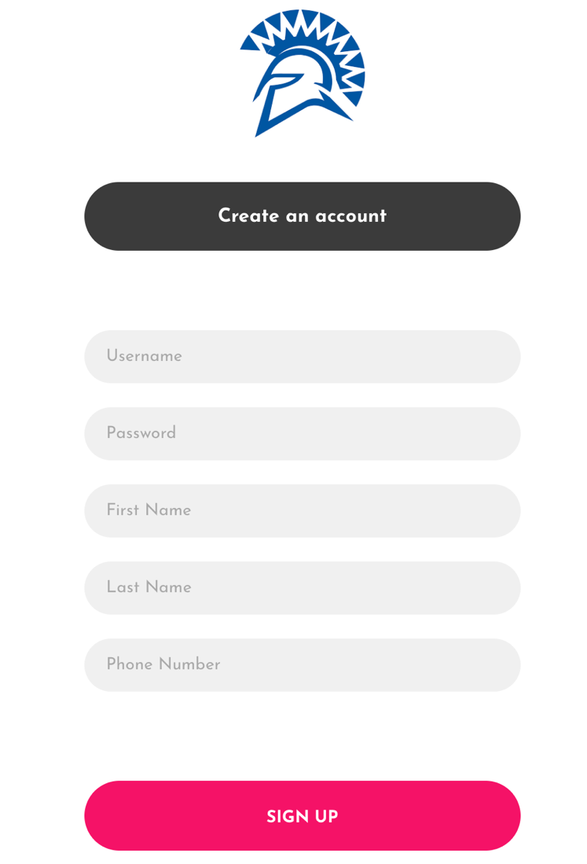

* + - login using user ID and password: users can login through their username and password which they have create already. We store the information in MySql table ‘users’.
    - save user’s information: when users login, they go to profile will find there information over there. And they could change their contact information through “edit profile”. Also link to MySql table ‘users’.
    - save user’s cart: when customers add items to cart, the carts will store items and show number of items. Such as 
* Describe each functionality/features, functional processes and I/O(s).
* Items
  + - Category: Women, Men, Books, Stationery
    - Item ID
    - Name
    - Price
    - Description
    - Image

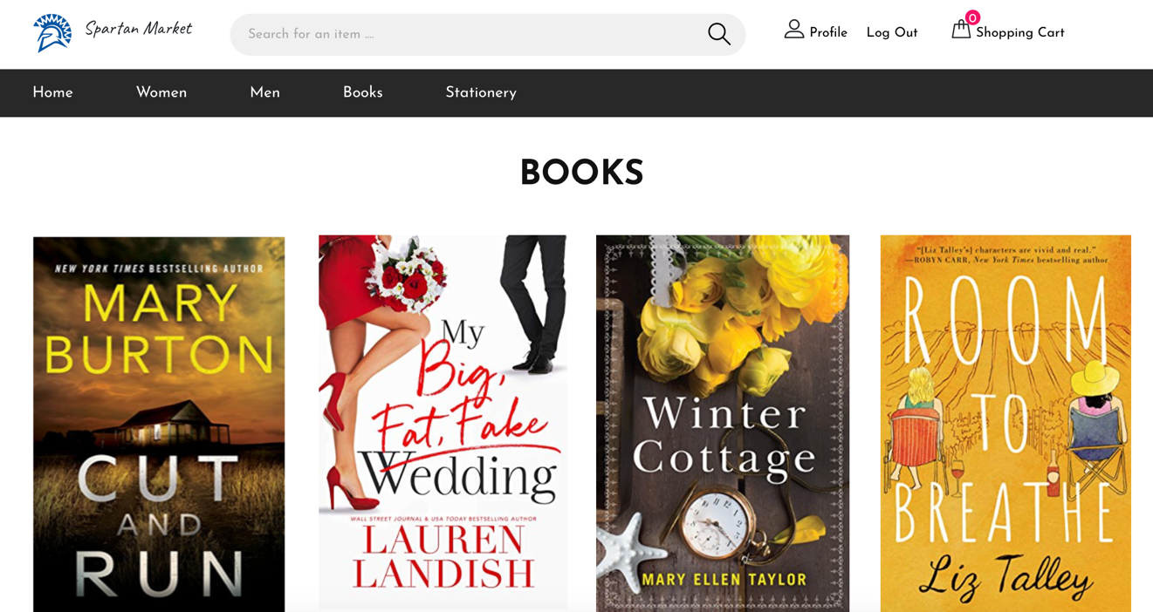

 

* Cart
* Items which users choose
* The amount of each item
* Payment page
* Items
* Total payment
* Enter address to ship
* Confirm payment method 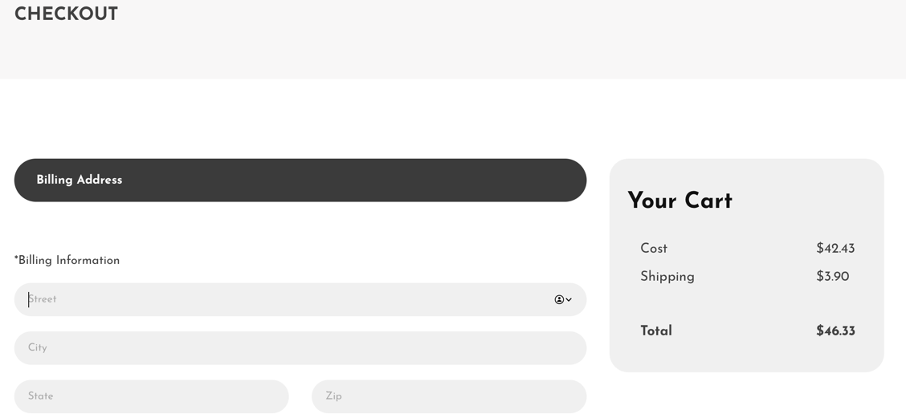
* Contact us
* Website information
* Email to contact
* **Non-functional Issues**

Types of Graphical User Interface (GUI) and Software tools to build GUI Security, access control, …

Software to build GUI

* Pug is a uses case sensitive syntax to generate html.
* JavaScript is written into an HTML page.
* Css describing the presentation of Web pages, including colors, layout, and fonts.
* Bootstrap is a framework to design websites.
* Colorlib template: we used template from colorlib (Joefrey) but not pages for a better and intuitive UI.

**Project Design**

1. Entity Sets
   1. *Users* – This set represents the ‘registered’ users in the application. By ‘registering’, the users provide us with personal data such as first name, last name, address, phone number and, set up a password for account creation.
   2. *PayingUsers* – Users become PayingUsers when they are in the middle of purchasing any items off the website. These users are asked to input their credit card information like, cardholder name, card number and address. An important point to note here, is that as PayingUsers have the same attributes as Users relation along with some attributes of its own, there is an ISA relationship between them.
   3. *Addresses* – This entity set collects all the addresses that are input in the website including, users’, paying users’ and suppliers’ addresses. Each entity in Addresses has a unique ID that will be used as foreign keys for its corresponding relationships.
   4. *Items* – This entity set represents all the items that are being sold in the website and have information like, name, description, stock, category, price, shipping days and is linked to a Supplier entity.
   5. *Suppliers* – This has information for all the suppliers who are selling the items on the website. Each entity is identified by a primary ID key, name, type of product associated with a supplier.
2. Relationships
   1. *HaveU, HavePU, HaveS* – These three relationships link a User, PayingUser and a Supplier to entities in Address, respectively. In our design, a User and a Supplier can have many addresses and also, the same address can be used by many Users, PayingUsers and Suppliers so, this is a Many-to-Many relationship.
   2. *Supply* – This relates a Supplier to an Item. An entity in Supply has information such as itemID and supplierID.
   3. *Carts* – Every paying user needs to have a Cart associated with it, so the items can be put there before a purchase. An entity in Carts has information such as userID, itemID, total price and quantity.
3. Schemas
   1. Users (User ID, Password, First Name, Last Name, Phone Number);
   2. Items (Item ID, Name, Description, Category, Price, image);
   3. Payingusers (CardNumber, CardHolderName, Expiration, CardsAccepted);
   4. Addresses (addressID, Street, City, State, Zip);
   5. Supplies (Supplier ID, Name);
   6. Supply (itemID, supplierID);
   7. HaveU (userID, addressesID);
   8. HavePU (PayingUsersCardNumber, addressesID);
   9. HaveS (supplierID, addressesID);

**Tables**

1. Addresses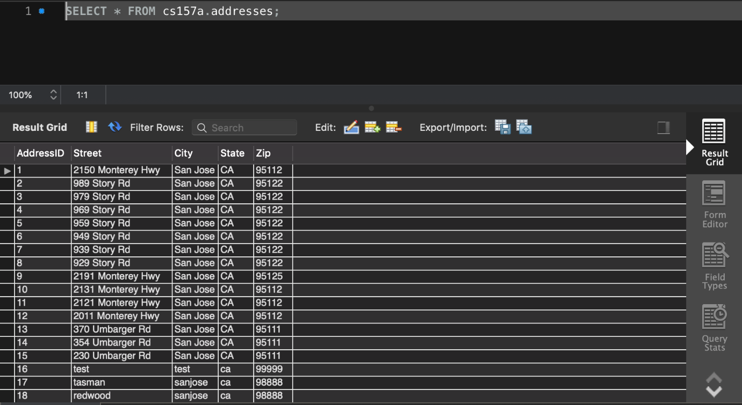
2. Carts 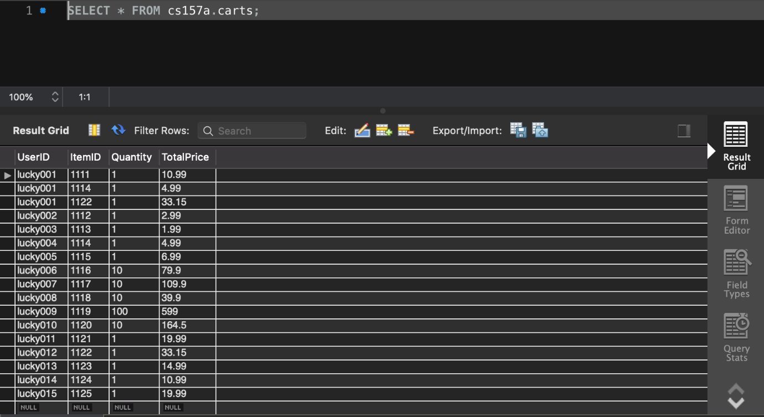
3. Havepu 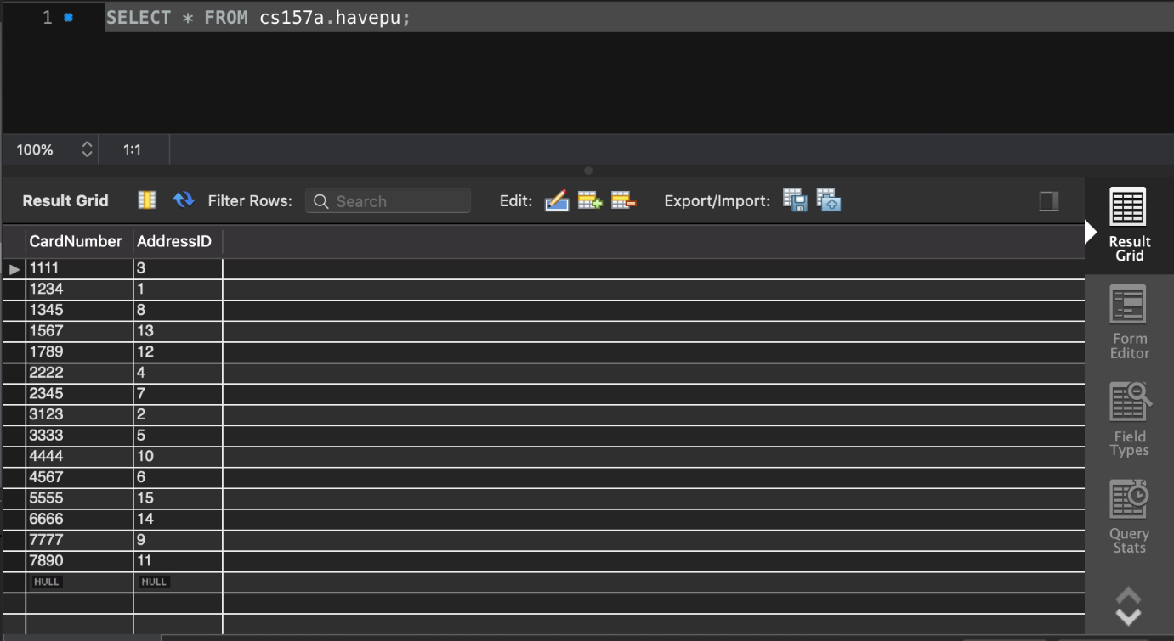
4. haveS 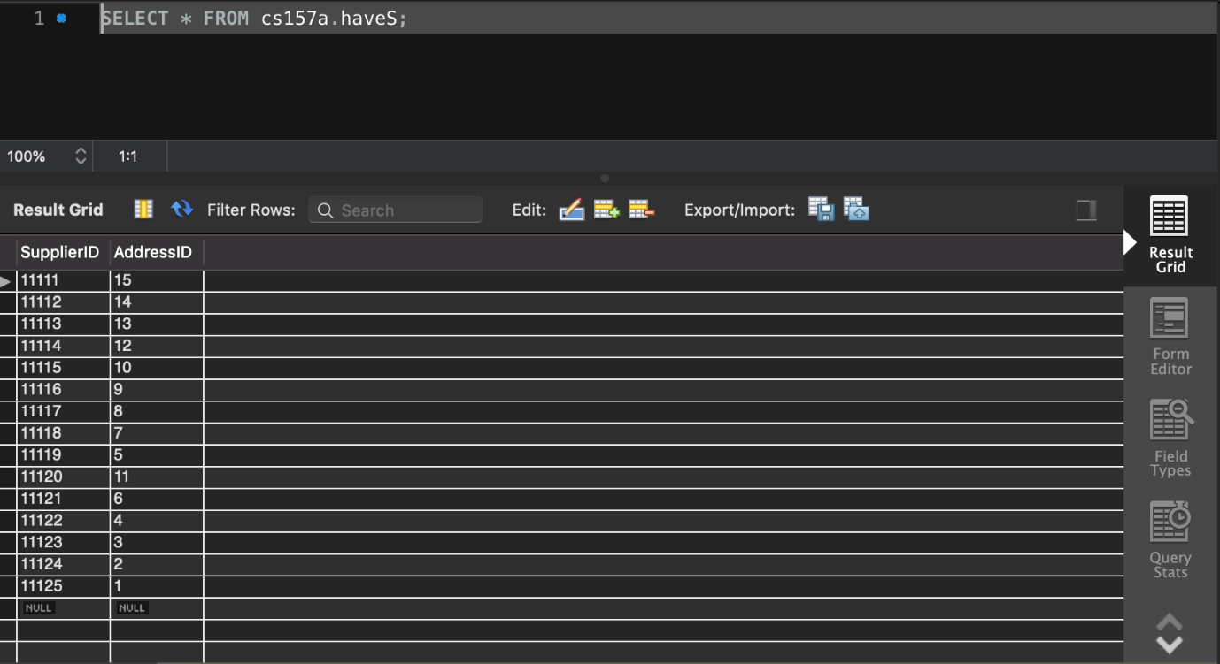
5. haveu 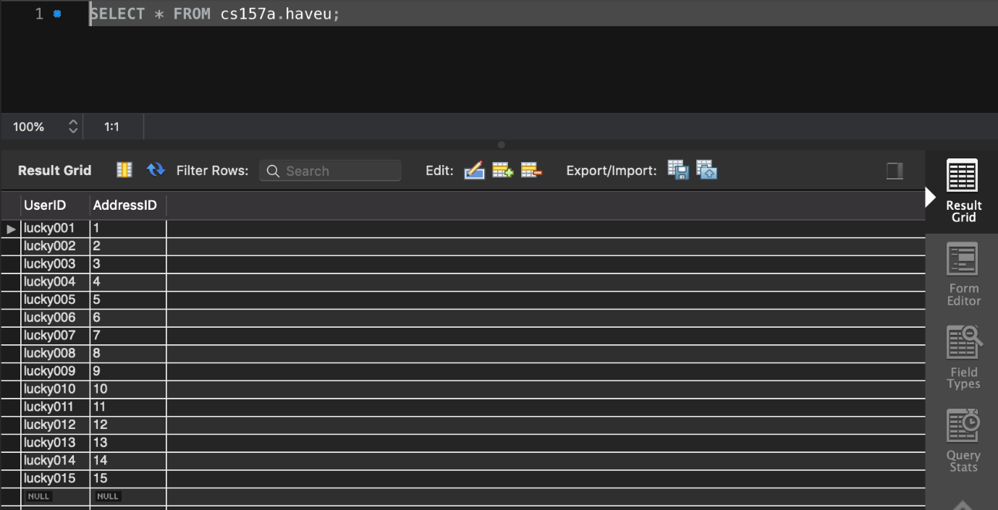
6. items 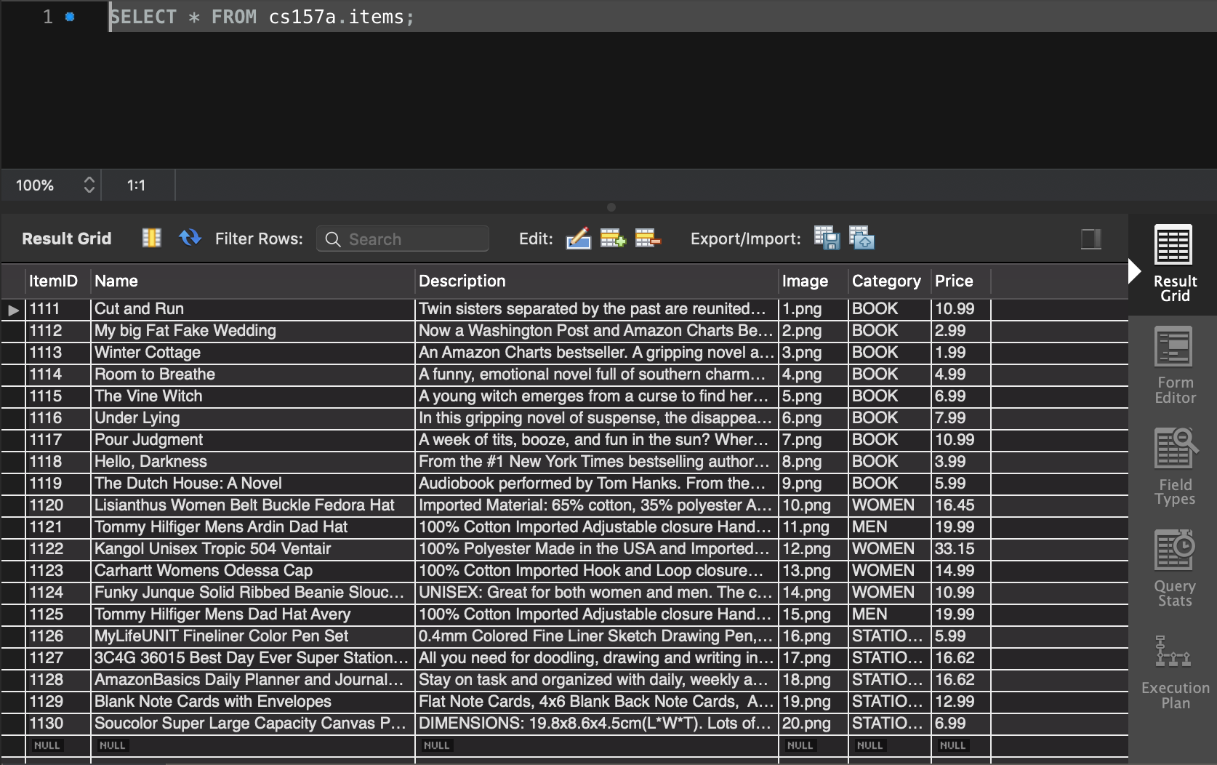
7. payingusers 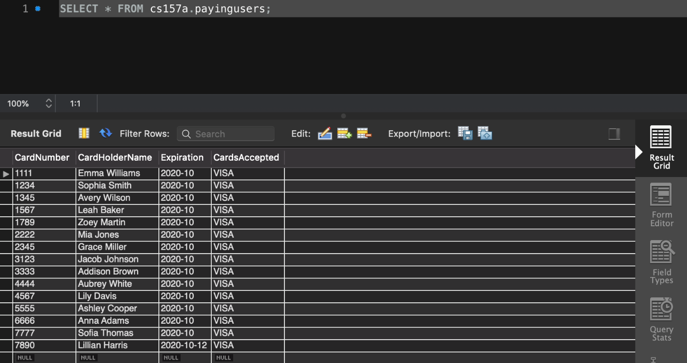
8. suppliers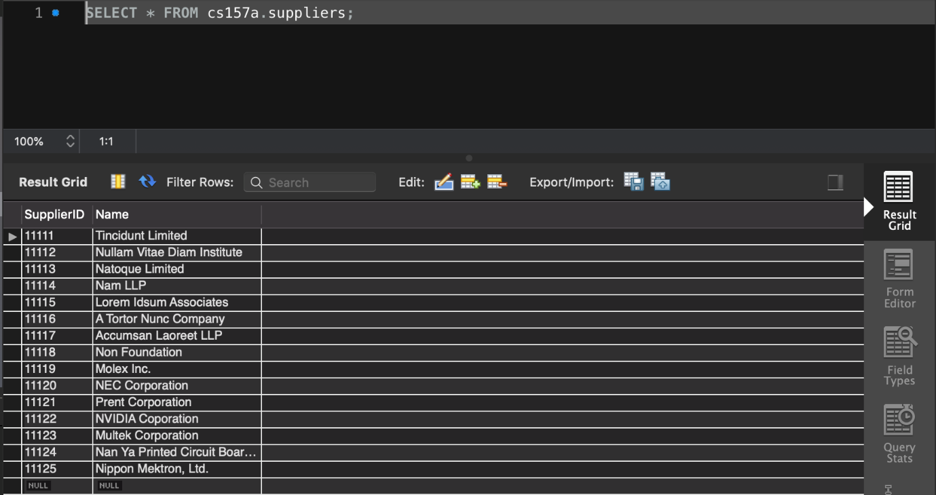
9. supply 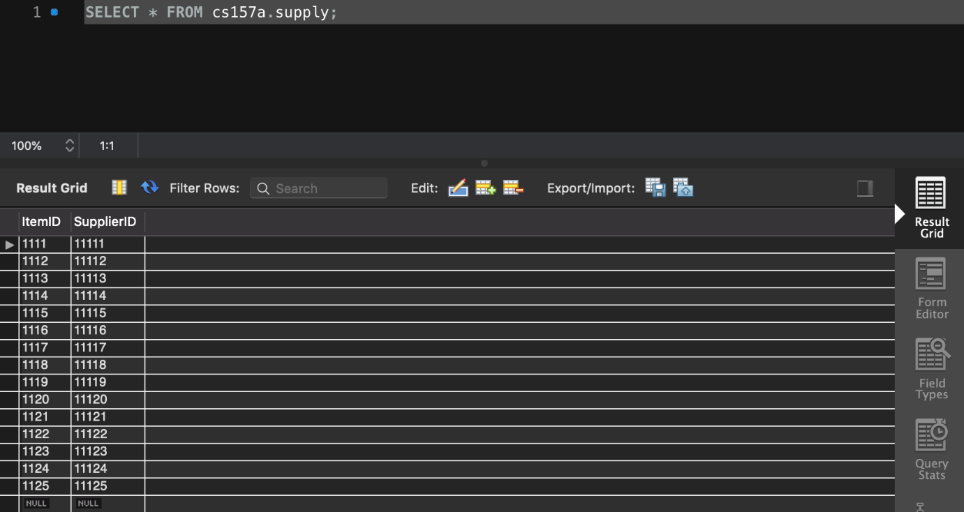
10. users 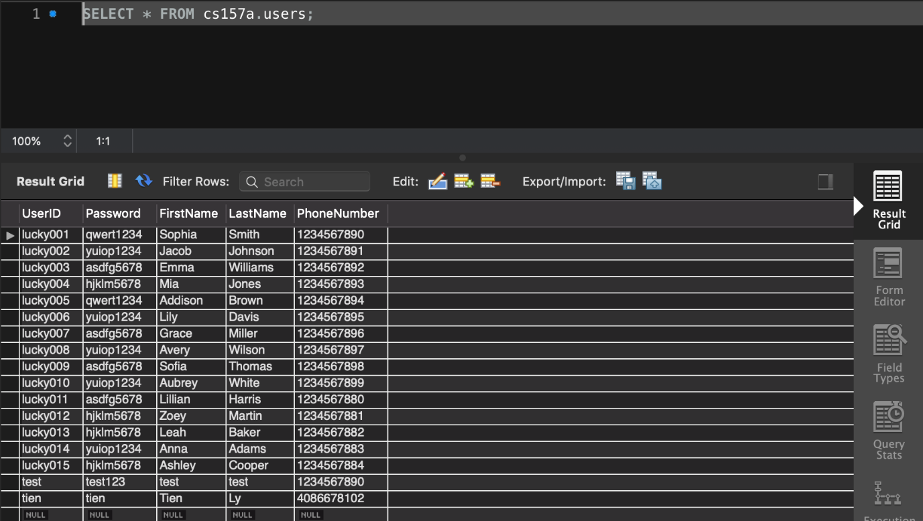

**Implementation**

* Functions associated with query:
* Home page shows all items from mysql.

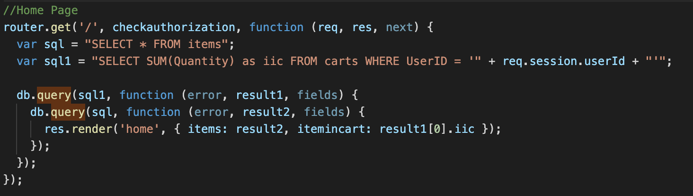

* Men page shows men’s stuff from mysql, SELECT * FROM items WHERE Category = ‘MEN’

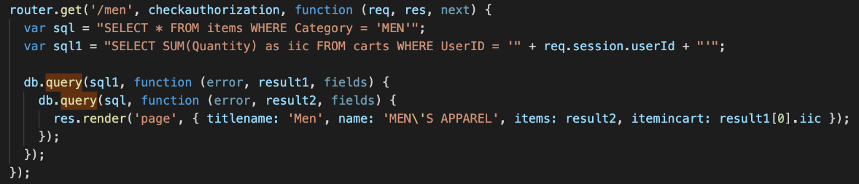

* Women page shows women’s stuff from mysql, SELECT * FROM items WHERE Category = ‘WOMEN’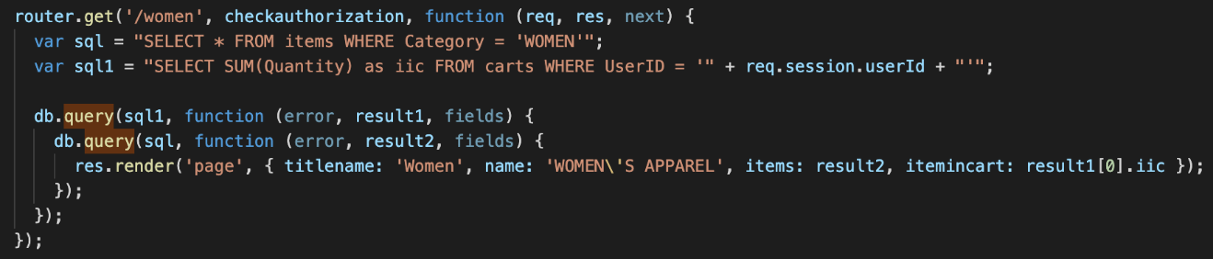
* Books page shows books from mysql, SELECT * FROM items WHERE Category = ‘BOOK’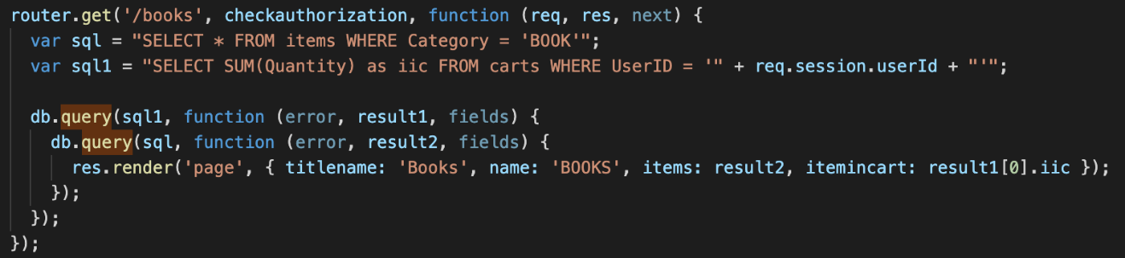
* Stationery page shows stationeries from mysql, SELECT * FROM items WHERE Category = ‘STATIONERY’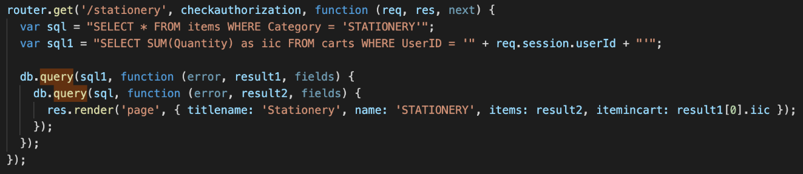
* Search using key words of items’ name, SELECT * FROM items WHERE Name LIKE

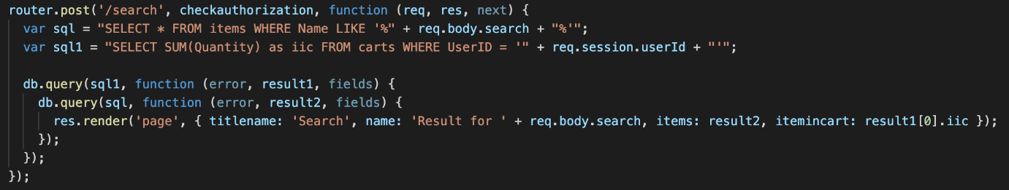

* Functions associated with insertion:
* Registration: insert users’ information to mysql.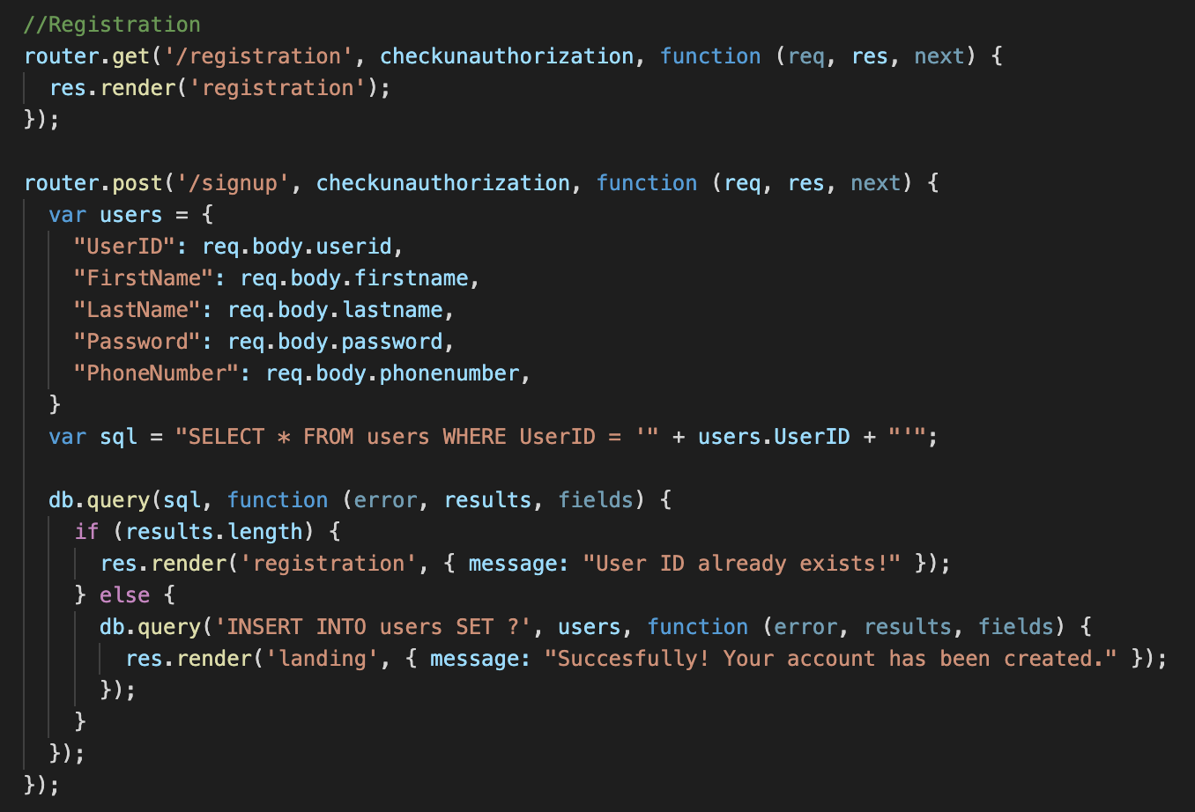
* Functions associated with updating:
* Cart button decrease: users can click the button to minus amount of the products.
* Cart button increase: users can click the button to add amount of the products. 
* Functions associated with deleting:
* Delete the cart when users have checkouted.

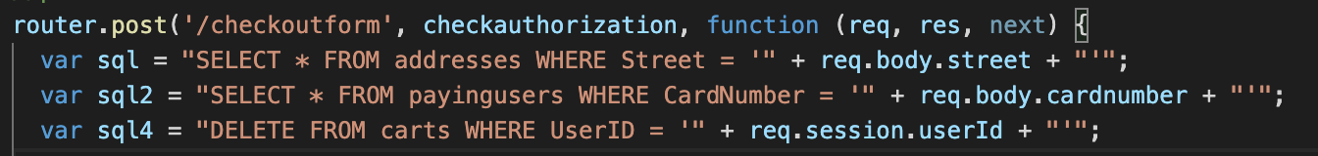

**Procedures of how to set up and run the system:**

1. Open folder by using VSC (Visual Studio Code)
2. Open routes in Terminal

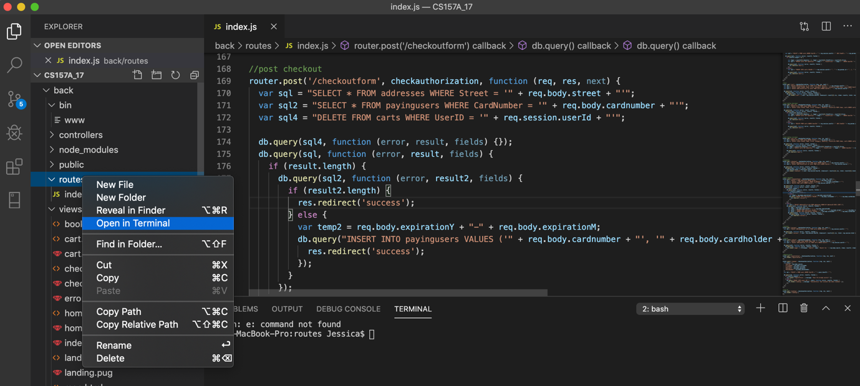

1. npm install
2. npm start: Database is connected.
3. Open the browser, using localhost:3000 to find the window.



1. It’s ready to use.



**Conclusion**

* Ge Ou:
  + Learned from the DB project: At first, I have learned 3-tiered architecture, which connect the whole project from front end, back end, and database. Second, I have learned ERD from the project design. Such as identify the entities, weak entity, attributes, relationships, inheritance, etc. Third, I familiar with JavaScript language through the project, and using html design pages.
  + Future improvement of our DB application: users can choose their stored billing information, card information, and delivery information from. We can open our store to users to sell their unused goods. Tables that users can insert items and belong to USED-attribute. Then users can add and delete their items.
* Tien Ly:
  + This is the first time I work and study about NodeJS also JavaScript. From other class, I knew about language Java, PHP, HTML, CSS but not NodeJS. From this project, I know how the session works, how to set up route, view, and database for NodeJS and MySQL. I also learn more things from bootstrap to set up template for front end. Pug engine is a good program for front end. It is simpler than html and has easier syntax. We can code directly mixing front end and back end data.
  + I learned about how to connect NodeJS with database MySQL and query to get, update, store, delete information in database. It was hard when I started but when I understand it, it is easy.
  + The project has many points to improve. The password needs to hash for security. User account needs the history of order/item they have purchased, needs pages to edit their information and change password, needs page to enter their address. The project needs function forgot password to look password for user. Higher improve: creating admin account to control users account also the items in the shop. Admin account should be able to add, delete, change the items information.

**Works Cited**

Smith, Felecia. 10 Benefits Of Reading. Technobezz, 14 Augest. 2018. https://www.technobezz.com/10-benefits-of-reading/

Joefrey. “Divisima - Free Clothing Website Template 2019.” Colorlib, 15 Jan. 2019, https://colorlib.com/wp/template/divisima/?fbclid=IwAR2-8TWoZc4rQ31ynGpdQWeXyM5qdfpRjHcwGZ4mHF29EkLlS3Nq32rMu3k.